***E-commerce Project***

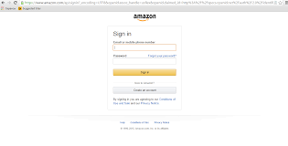



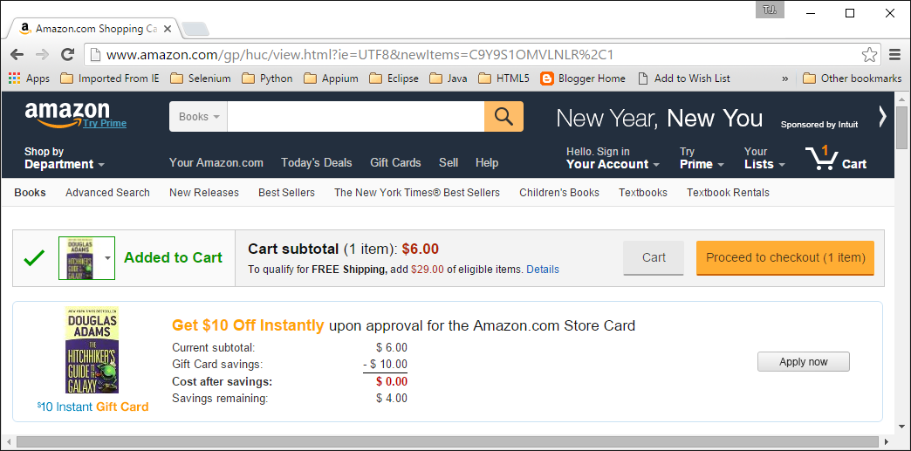

***Usability testing in e-commerce site***

|  |  |  |  |  |  |  |
| --- | --- | --- | --- | --- | --- | --- |
|  | 1. Define usability criteria for evaluation. 2. Gather feedback and implement improvements. 3. Conduct usability tests with real users.  |  | | --- | | **User interface testing in e-commerce site** | |  |  | |  |  | |

1. Verify that the font size throughout the application is as expected.
2. Verify that the font color is the same on all web pages and is as expected.
3. Verify that there are no spelling mistakes on the entire website.
4. Verify that there are no spelling errors in the error messages.
5. Verify that the label text is visible or not.
6. Verify that the header text and regular text are clear and readable.
7. Verify that the label text is visible or not.
8. Verify that the header text and regular text are clear and readable.
9. Verify that the logo is in the appropriate position as per the requirements.
10. Verify that the header text of the page is displaying correctly.

**Smoke testing in e-commerce site**

smoke test for each of the following processes:

* Create a user profile
* Select an item
* Add to cart
* Check out

You can expand this list depending on the complexity of your website, for every key interaction users will take across the entire site.

Smoke testing generally happens before the QA team deploys functional testing on the website or web application. If the QA team finds errors in the software during a smoke test, it is sent back to the developers, and the cycle breaks itself off there. Because functional testing and other formal testing efforts take time and resources, it’s wise to smoke test the system before it is sent on for further testing.

A smoke test determines whether the software is stable. With smoke testing you can also check whether the software complies with the requirements that were initially set for its construction – that is, does the website deliver what is expected? This builds an initial confidence in the software, which can further be developed through more rigorous testing efforts as you move toward production.